TEAM BONDING SESSION REPORT:

| EVENT  NAME | GDSC Team Bonding Session |
| --- | --- |
| DATE | 8th October 2023 |
| TIME | 12PM-5PM |
| VENUE | Amanora Temple of Environment, Hadapsar |
| AGENDA | . 12.00 PM- Team members assemble at the venue  . 12.30 PM- Team interaction and bonding followed by outdoor activities  and games.  . 2.00 PM- Heading to Amanora mall for Team Lunch |

Summary:

The session was held by the GDSC Lead, Mr.Akshat Vashisht, in an attempt to bond with the team and hold interactions so that every member from each team knows each other. The session began with members assembling at the Amanora Park followed by an activity that facilitated the members to introduce themselves and interact with fellow members and the Lead.

Everyone had a wonderful time !

Thereafter, the bonding session continued with various fun outdoor games organised and facilitated by the Lead through which the team learnt values like leadership, co-operation and teamwork along with having a good time.

This followed with a nice team lunch filled with delicious food and joyful discussions amongst the team members. Various team pictures were taken capturing beautiful memories and the event ended with the team gaining a newfound and strong motivation to work together.

A few glimpses of the Event

Team Interaction

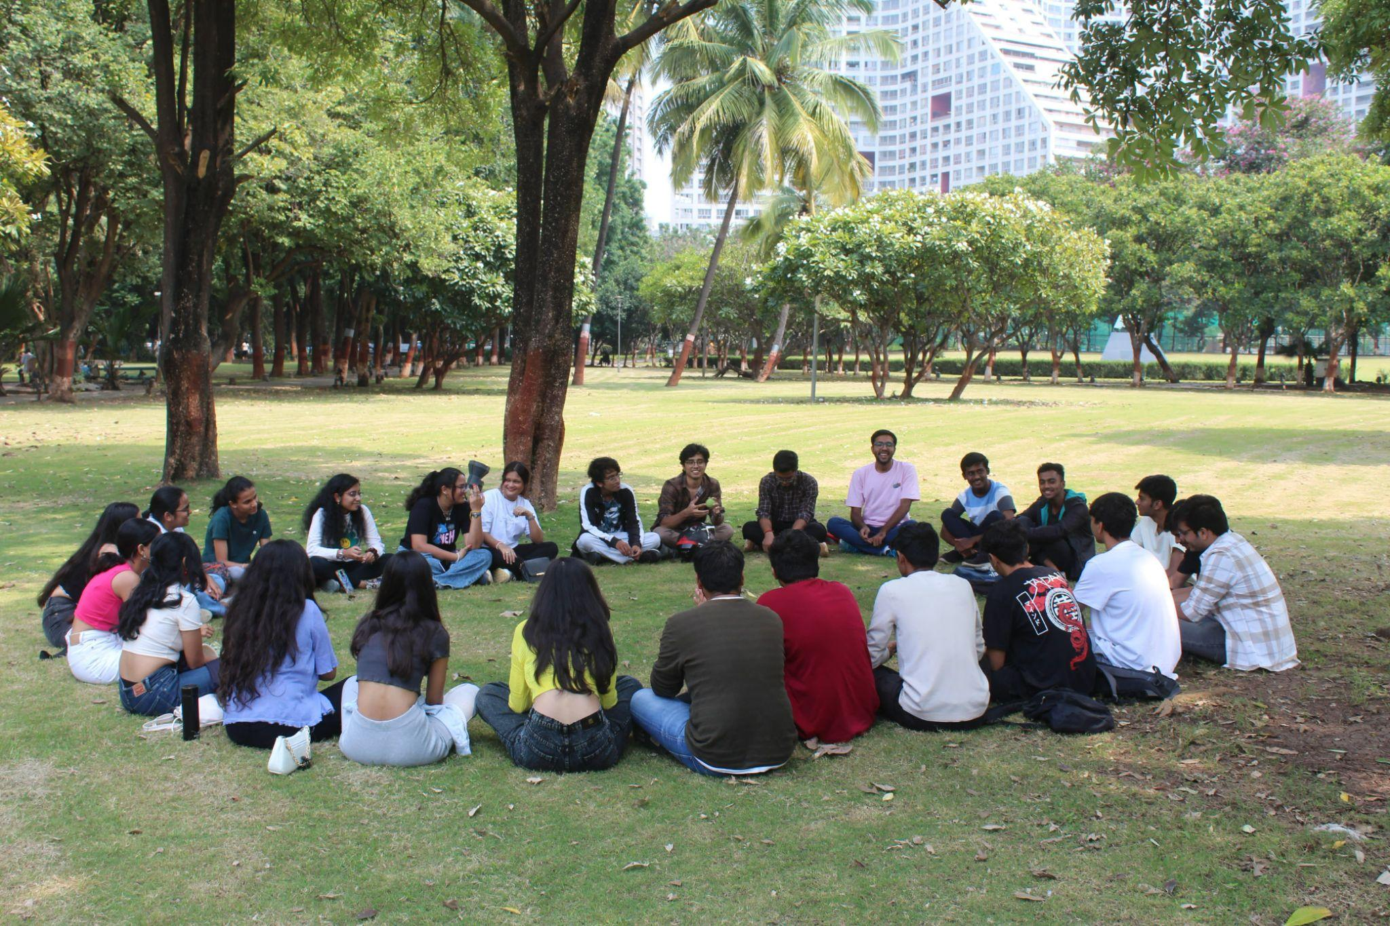

Playing games

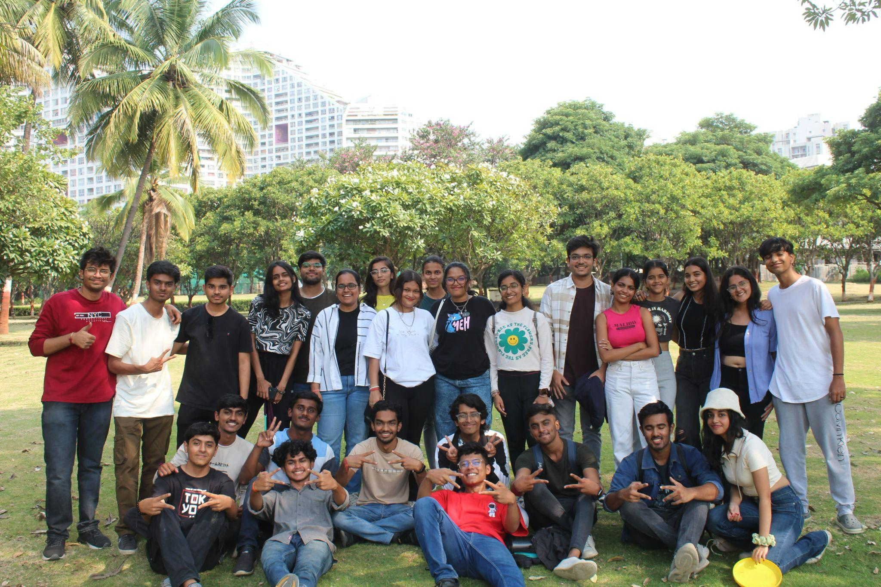

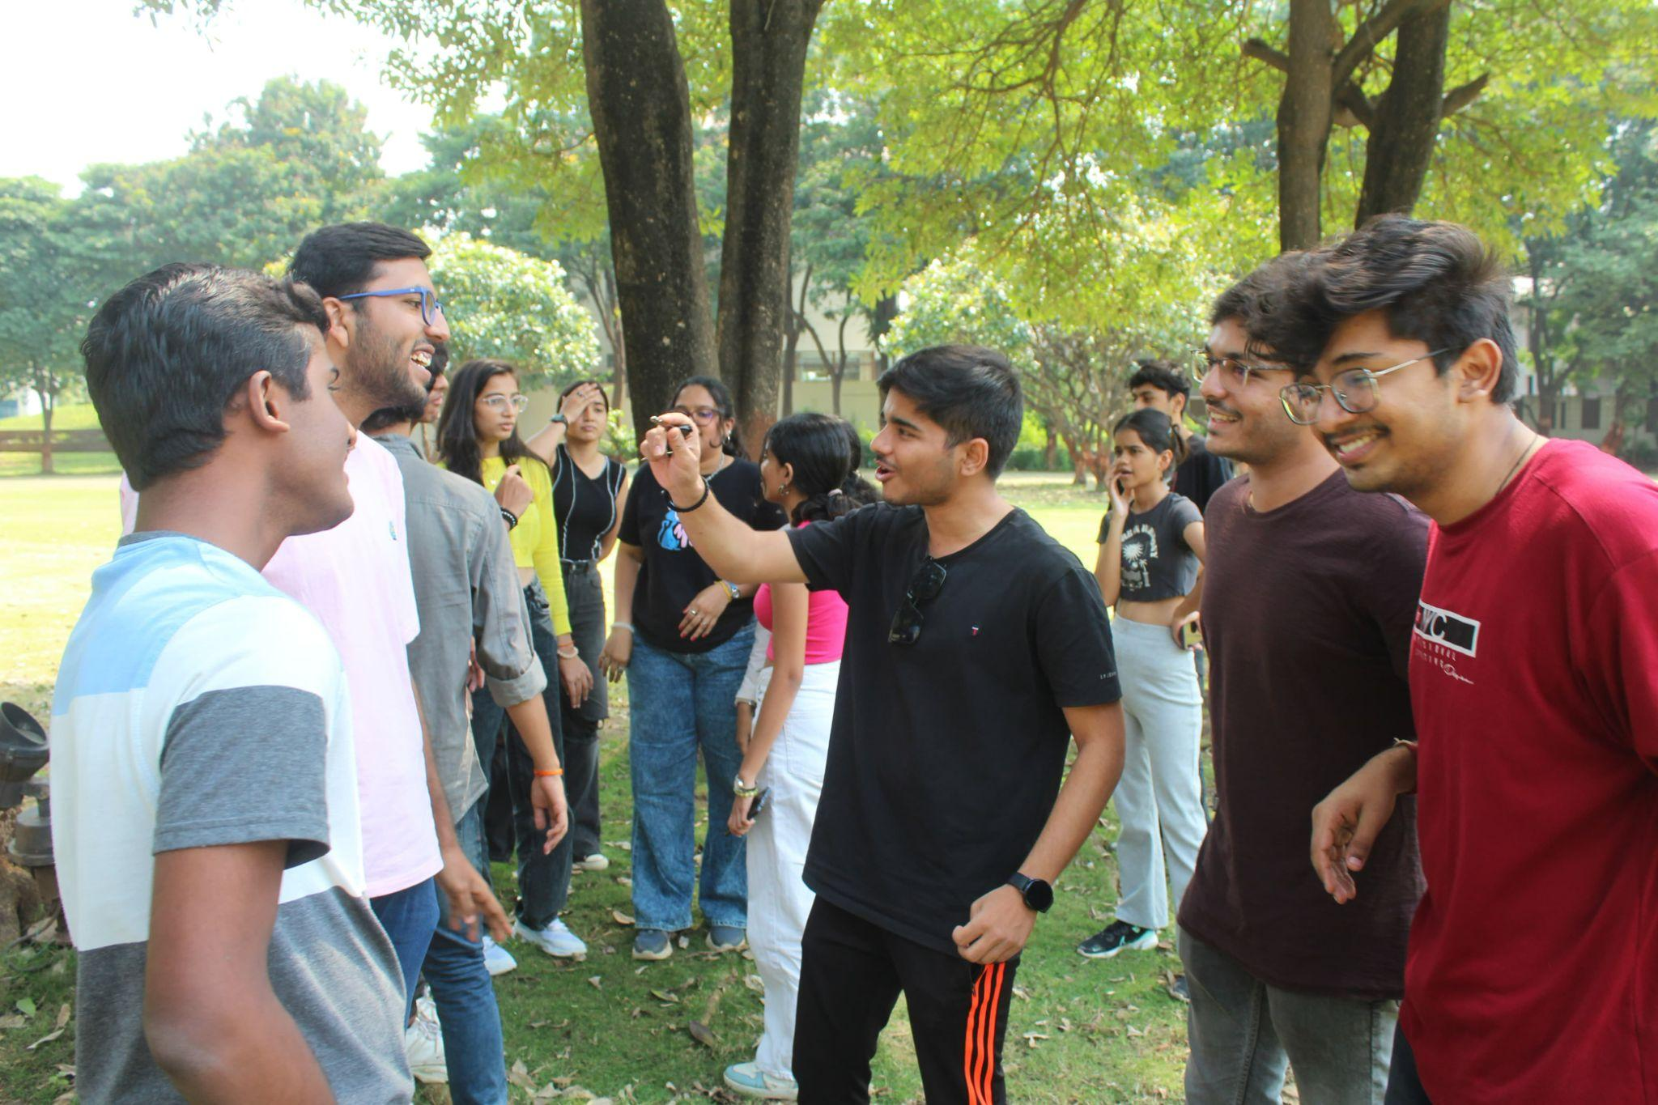

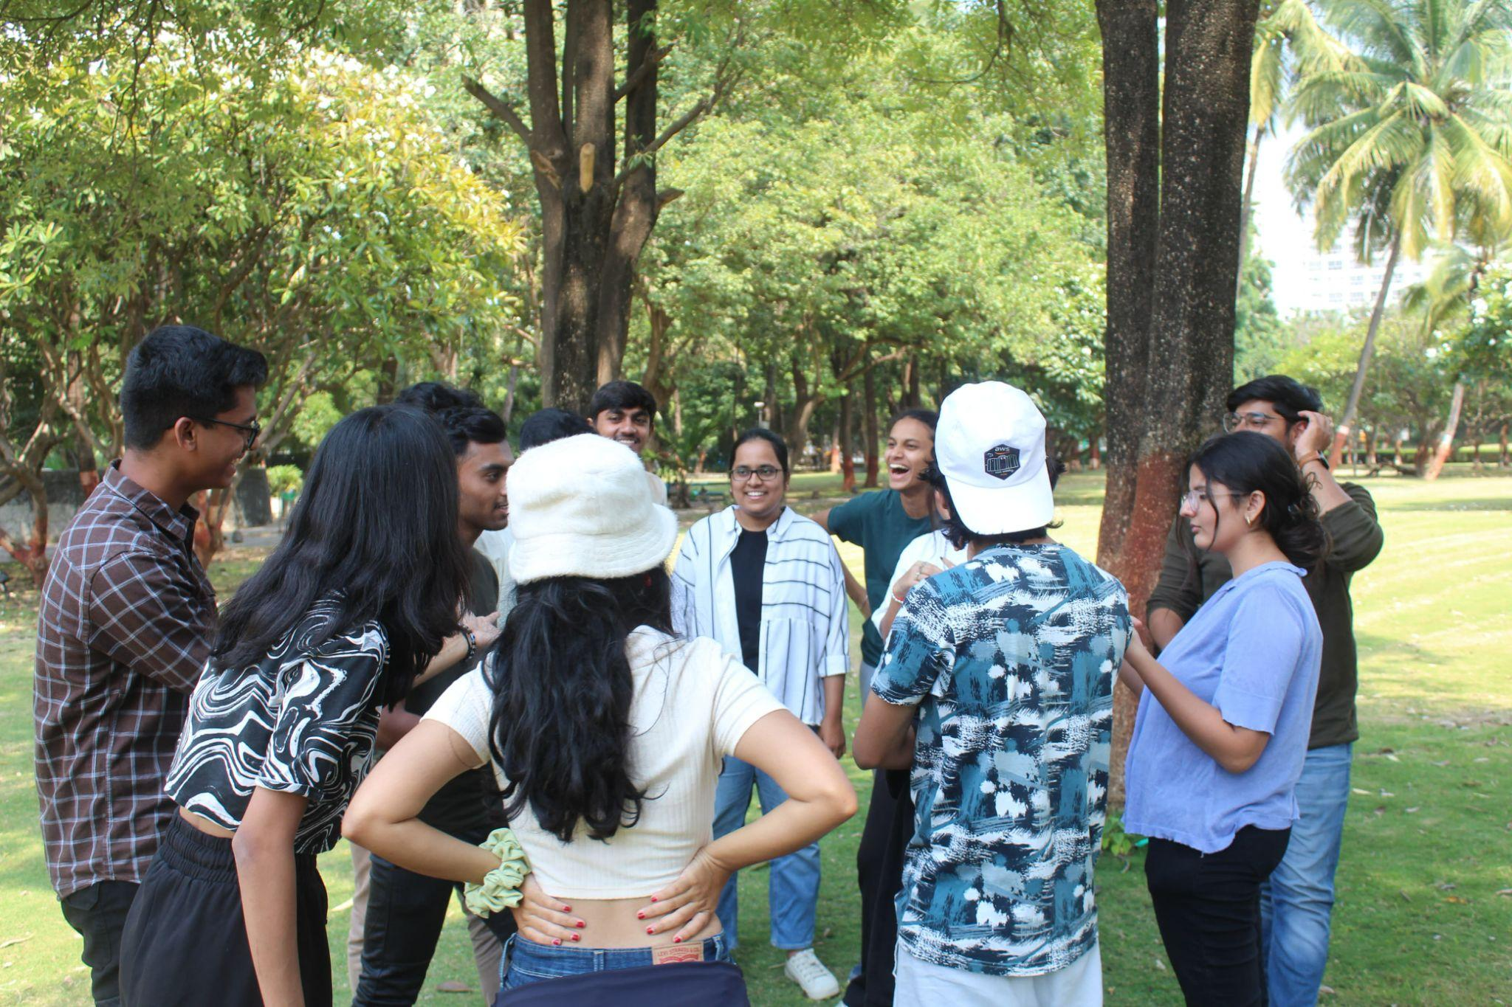

After team lunch

